How to Get Project Meta Data

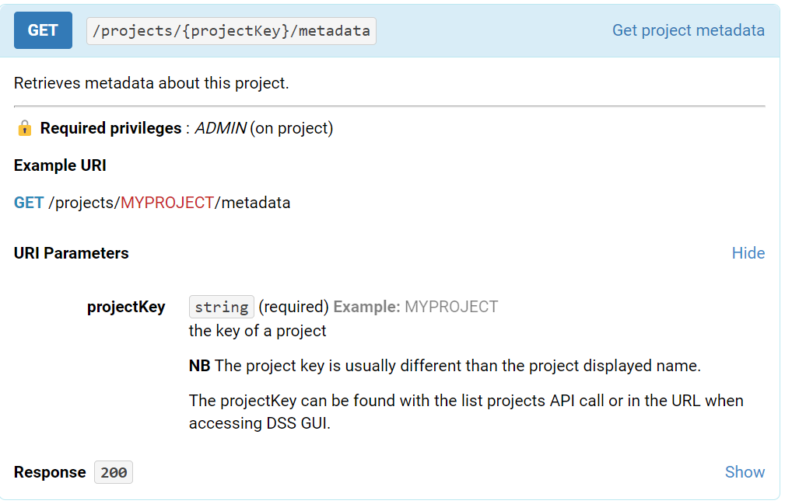

Updates metadata about this project. You should only set a metadata object that has been obtained through the corresponding GET call.

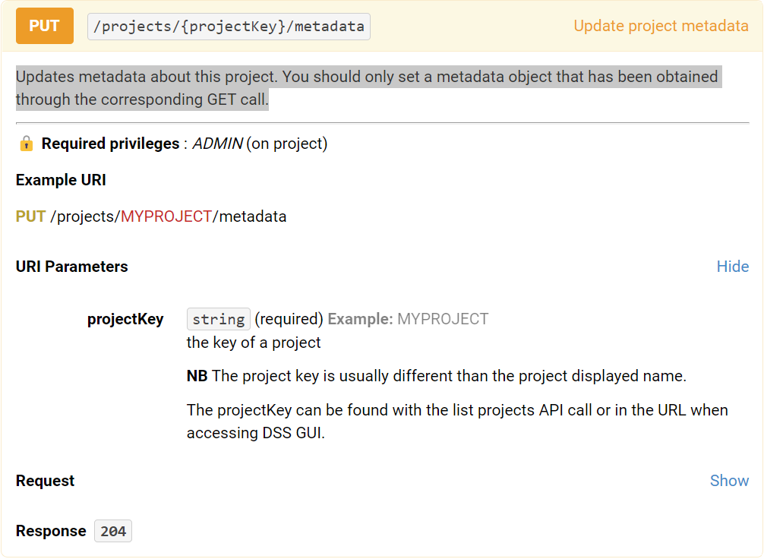

Retrieves project-level variables for this project.

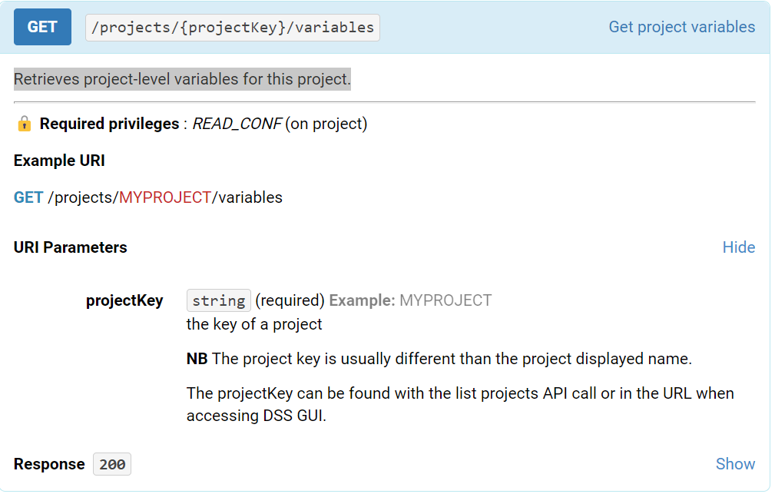

Updates project-level variables for this project. You should only set a variables object that has been obtained through the corresponding GET call.

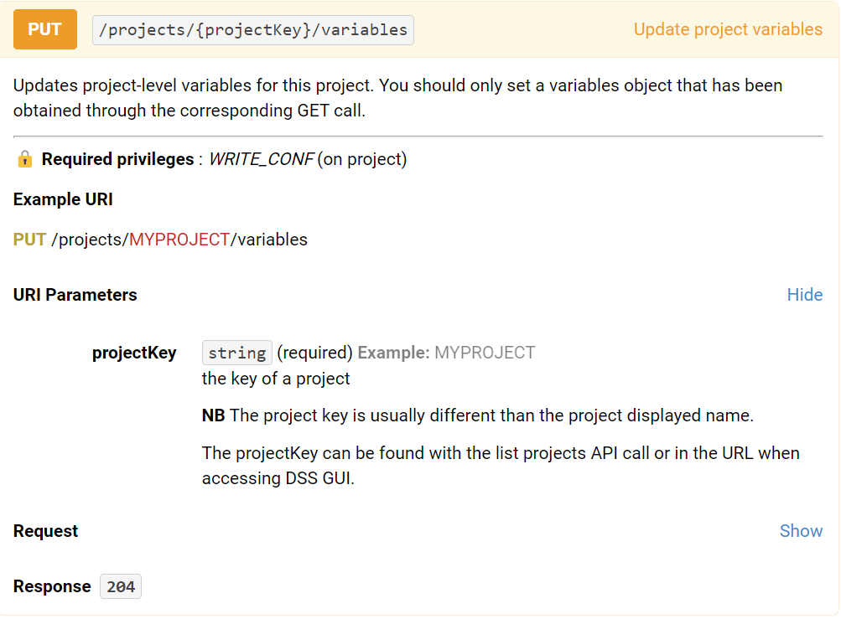

Duplicate a project.

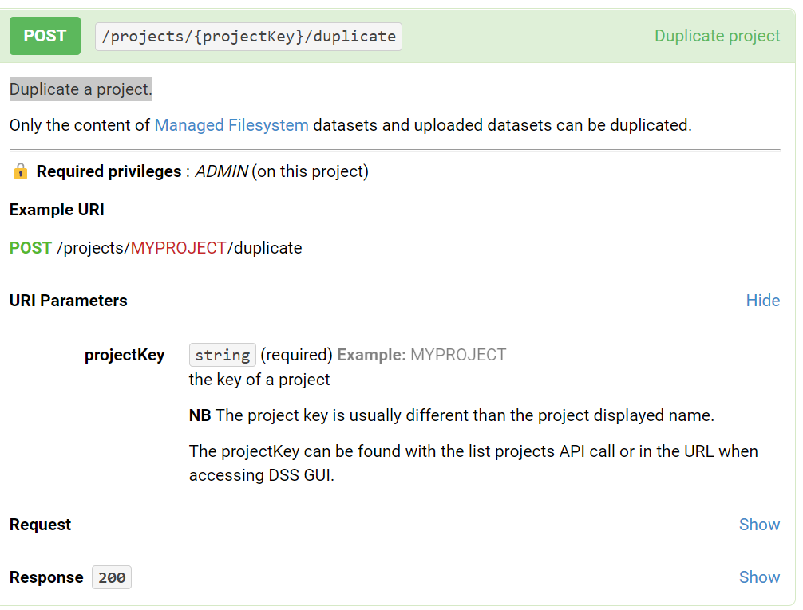

Pushes the content from remote Git

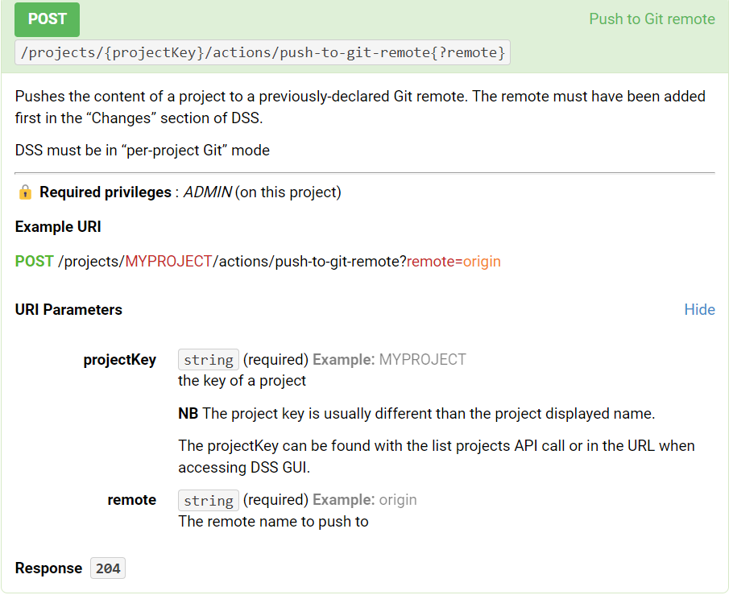

**DATASET METADATA**

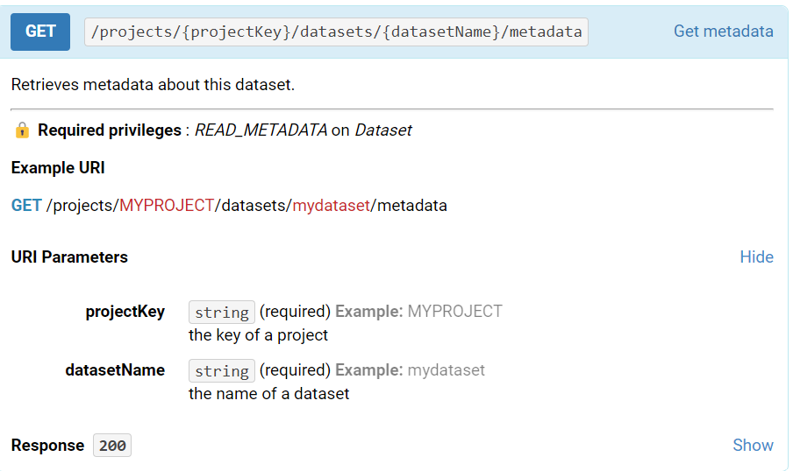

### RECIPES